**Tool# 1**

**NAVBAR WITH BOOTRAPE TOOLS (WITH OUTPUT)**

<!DOCTYPE html>

<html lang="en">

<head>

<meta charset="utf-8">

<meta name="viewport" content="width=device-width, initial-scale=1">

<title>Bootstrap Navbar Color Schemes</title>

<link href="https://cdn.jsdelivr.net/npm/bootstrap@5.0.2/dist/css/bootstrap.min.css" rel="stylesheet">

<link rel="stylesheet" href="https://cdn.jsdelivr.net/npm/bootstrap-icons@1.5.0/font/bootstrap-icons.css">

<script src="https://cdn.jsdelivr.net/npm/bootstrap@5.0.2/dist/js/bootstrap.bundle.min.js"></script>

<style>

/* Custom style */

.navbar{

margin-bottom: 1rem;

}

</style>

</head>

<body>

<div class="m-4">

<nav class="navbar navbar-expand-lg navbar-dark bg-dark">

<div class="container-fluid">

<a href="#" class="navbar-brand">Brand</a>

<button type="button" class="navbar-toggler" data-bs-toggle="collapse" data-bs-target="#navbarCollapse1">

<span class="navbar-toggler-icon"></span>

</button>

<div class="collapse navbar-collapse" id="navbarCollapse1">

<!DOCTYPE html>

<html lang="en">

<head>

<meta charset="utf-8">

<meta name="viewport" content="width=device-width, initial-scale=1">

<title>Bootstrap Navbar Color Schemes</title>

<link href="https://cdn.jsdelivr.net/npm/bootstrap@5.0.2/dist/css/bootstrap.min.css" rel="stylesheet">

<link rel="stylesheet" href="https://cdn.jsdelivr.net/npm/bootstrap-icons@1.5.0/font/bootstrap-icons.css">

<script src="https://cdn.jsdelivr.net/npm/bootstrap@5.0.2/dist/js/bootstrap.bundle.min.js"></script>

<style>

/* Custom style */

.navbar{

margin-bottom: 1rem;

}

</style>

</head>

<body>

<div class="m-4">

<nav class="navbar navbar-expand-lg navbar-dark bg-dark">

<div class="container-fluid">

<a href="#" class="navbar-brand">Brand</a>

<button type="button" class="navbar-toggler" data-bs-toggle="collapse" data-bs-target="#navbarCollapse1">

<span class="navbar-toggler-icon"></span>

</button>

<div class="collapse navbar-collapse" id="navbarCollapse1">

<div class="navbar-nav">

<a href="#" class="nav-item nav-link active">Home</a>

<a href="#" class="nav-item nav-link">About</a>

<a href="#" class="nav-item nav-link">Products</a>

</div>

<form class="d-flex ms-auto">

<input type="text" class="form-control me-sm-2" placeholder="Search">

<button type="submit" class="btn btn-outline-light">Search</button>

</form>

</div>

</div>

</nav>

<nav class="navbar navbar-expand-lg navbar-dark bg-primary">

<div class="container-fluid">

<a href="#" class="navbar-brand">Brand</a>

<button type="button" class="navbar-toggler" data-bs-toggle="collapse" data-bs-target="#navbarCollapse2">

<span class="navbar-toggler-icon"></span>

</button>

<div class="collapse navbar-collapse" id="navbarCollapse2">

<div class="navbar-nav">

<a href="#" class="nav-item nav-link active">Home</a>

<a href="#" class="nav-item nav-link">About</a>

<a href="#" class="nav-item nav-link">Products</a>

</div>

<form class="d-flex ms-auto">

<input type="text" class="form-control me-sm-2" placeholder="Search">

<button type="submit" class="btn btn-outline-light">Search</button>

</form>

</div>

</div>

</nav>

<nav class="navbar navbar-expand-lg navbar-dark bg-secondary">

<div class="container-fluid">

<a href="#" class="navbar-brand">Brand</a>

<button type="button" class="navbar-toggler" data-bs-toggle="collapse" data-bs-target="#navbarCollapse3">

<span class="navbar-toggler-icon"></span>

</button>

<div class="collapse navbar-collapse" id="navbarCollapse3">

<div class="navbar-nav">

<a href="#" class="nav-item nav-link active">Home</a>

<a href="#" class="nav-item nav-link">About</a>

<a href="#" class="nav-item nav-link">Products</a>

</div>

<form class="d-flex ms-auto">

<input type="text" class="form-control me-sm-2" placeholder="Search">

<button type="submit" class="btn btn-outline-light">Search</button>

</form>

</div>

</div>

</nav>

<nav class="navbar navbar-expand-lg navbar-dark bg-success">

<div class="container-fluid">

<a href="#" class="navbar-brand">Brand</a>

<button type="button" class="navbar-toggler" data-bs-toggle="collapse" data-bs-target="#navbarCollapse4">

<span class="navbar-toggler-icon"></span>

</button>

<div class="collapse navbar-collapse" id="navbarCollapse4">

<div class="navbar-nav">

<a href="#" class="nav-item nav-link active">Home</a>

<a href="#" class="nav-item nav-link">About</a>

<a href="#" class="nav-item nav-link">Products</a>

</div>

<form class="d-flex ms-auto">

<input type="text" class="form-control me-sm-2" placeholder="Search">

<button type="submit" class="btn btn-outline-light">Search</button>

</form>

</div>

</div>

</nav>

<nav class="navbar navbar-expand-lg navbar-dark bg-info">

<div class="container-fluid">

<a href="#" class="navbar-brand">Brand</a>

<button type="button" class="navbar-toggler" data-bs-toggle="collapse" data-bs-target="#navbarCollapse5">

<span class="navbar-toggler-icon"></span>

</button>

<div class="collapse navbar-collapse" id="navbarCollapse5">

<div class="navbar-nav">

<a href="#" class="nav-item nav-link active">Home</a>

<a href="#" class="nav-item nav-link">About</a>

<a href="#" class="nav-item nav-link">Products</a>

</div>

<form class="d-flex ms-auto">

<input type="text" class="form-control me-sm-2" placeholder="Search">

<button type="submit" class="btn btn-outline-light">Search</button>

</form>

</div>

</div>

</nav>

<nav class="navbar navbar-expand-lg navbar-dark bg-danger">

<div class="container-fluid">

<a href="#" class="navbar-brand">Brand</a>

<button type="button" class="navbar-toggler" data-bs-toggle="collapse" data-bs-target="#navbarCollapse6">

<span class="navbar-toggler-icon"></span>

</button>

<div class="collapse navbar-collapse" id="navbarCollapse6">

<div class="navbar-nav">

<a href="#" class="nav-item nav-link active">Home</a>

<a href="#" class="nav-item nav-link">About</a>

<a href="#" class="nav-item nav-link">Products</a>

</div>

<form class="d-flex ms-auto">

<input type="text" class="form-control me-sm-2" placeholder="Search">

<button type="submit" class="btn btn-outline-light">Search</button>

</form>

</div>

</div>

</nav>

<nav class="navbar navbar-expand-lg navbar-dark bg-warning">

<div class="container-fluid">

<a href="#" class="navbar-brand">Brand</a>

<button type="button" class="navbar-toggler" data-bs-toggle="collapse" data-bs-target="#navbarCollapse7">

<span class="navbar-toggler-icon"></span>

</button>

<div class="collapse navbar-collapse" id="navbarCollapse7">

<div class="navbar-nav">

<a href="#" class="nav-item nav-link active">Home</a>

<a href="#" class="nav-item nav-link">About</a>

<a href="#" class="nav-item nav-link">Products</a>

</div>

<form class="d-flex ms-auto">

<input type="text" class="form-control me-sm-2" placeholder="Search">

<button type="submit" class="btn btn-outline-light">Search</button>

</form>

</div>

</div>

</nav>

<nav class="navbar navbar-expand-lg navbar-light bg-light">

<div class="container-fluid">

<a href="#" class="navbar-brand">Brand</a>

<button type="button" class="navbar-toggler" data-bs-toggle="collapse" data-bs-target="#navbarCollapse8">

<span class="navbar-toggler-icon"></span>

</button>

<div class="collapse navbar-collapse" id="navbarCollapse8">

<div class="navbar-nav">

<a href="#" class="nav-item nav-link active">Home</a>

<a href="#" class="nav-item nav-link">About</a>

<a href="#" class="nav-item nav-link">Products</a>

</div>

<form class="d-flex ms-auto">

<input type="text" class="form-control me-sm-2" placeholder="Search">

<button type="submit" class="btn btn-outline-secondary">Search</button>

</form>

</div>

</div>

</nav>

<nav class="navbar navbar-expand-lg navbar-light" style="background-color: #e3f2fd;">

<div class="container-fluid">

<a href="#" class="navbar-brand">Brand</a>

<button type="button" class="navbar-toggler" data-bs-toggle="collapse" data-bs-target="#navbarCollapse9">

<span class="navbar-toggler-icon"></span>

</button>

<div class="collapse navbar-collapse" id="navbarCollapse9">

<div class="navbar-nav">

<a href="#" class="nav-item nav-link active">Home</a>

<a href="#" class="nav-item nav-link">About</a>

<a href="#" class="nav-item nav-link">Products</a>

</div>

<form class="d-flex ms-auto">

<input type="text" class="form-control me-sm-2" placeholder="Search">

<button type="submit" class="btn btn-outline-primary">Search</button>

</form>

</div>

</div>

</nav>

</div>

</body>

</html>

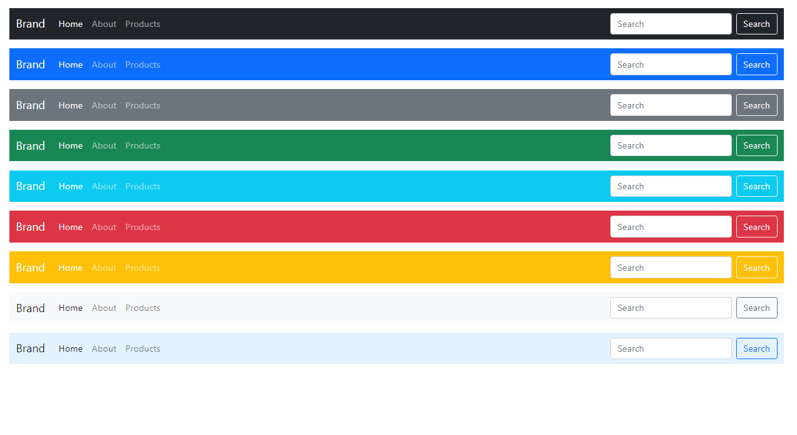

**Nav bar with logo and with bootsrapes**

<!DOCTYPE html>

<html lang="en">

<head>

<meta charset="utf-8">

<meta name="viewport" content="width=device-width, initial-scale=1">

<title>Bootstrap Navbar with Logo Image</title>

<link href="https://cdn.jsdelivr.net/npm/bootstrap@5.0.2/dist/css/bootstrap.min.css" rel="stylesheet">

<script src="https://cdn.jsdelivr.net/npm/bootstrap@5.0.2/dist/js/bootstrap.bundle.min.js"></script>

</head>

<body>

<div class="m-4">

    <nav class="navbar navbar-expand-lg navbar-light bg-light">

        <div class="container-fluid">

            <a href="#" class="navbar-brand">

                <img src="C:\Users\kfmss1967\Documents\Pepsi Website\images\pepsi logo.png" height="28" alt="CoolBrand">

            </a>

            <button type="button" class="navbar-toggler" data-bs-toggle="collapse" data-bs-target="#navbarCollapse">

                <span class="navbar-toggler-icon"></span>

            </button>

            <div class="collapse navbar-collapse" id="navbarCollapse">

                <div class="navbar-nav">

                    <a href="#" class="nav-item nav-link active">Home</a>

                    <a href="#" class="nav-item nav-link">Profile</a>

                    <a href="#" class="nav-item nav-link">Messages</a>

                    <a href="#" class="nav-item nav-link disabled" tabindex="-1">Reports</a>

                </div>

                <div class="navbar-nav ms-auto">

                    <a href="#" class="nav-item nav-link">Login</a>

                </div>

            </div>

        </div>

    </nav>

</div>

</body>

</html>

<script type="text/javascript" async="" src="//www.lightboxcdn.com/vendor/ad747954-11bc-42e8-af3d-8372ebfb45e4/user.js?cb=638100992533980601"></script>



**Animated slides**

<https://getbootstrap.com/docs/5.0/components/carousel/>

**Sliders links**

https://freshdesignweb.com/jquery-image-slider-slideshow/

**Complete course of W3School**

<https://www.w3docs.com/course/css-the-complete-guide-2020-incl-flexbox-grid-sass>

**Marquee Text**

https://www.w3docs.com/learn-html/html-marquee-tag.html

Beatiful Buttons

https://codepen.io/yuhomyan/pen/OJMejWJ